USMAN SARFRAZ  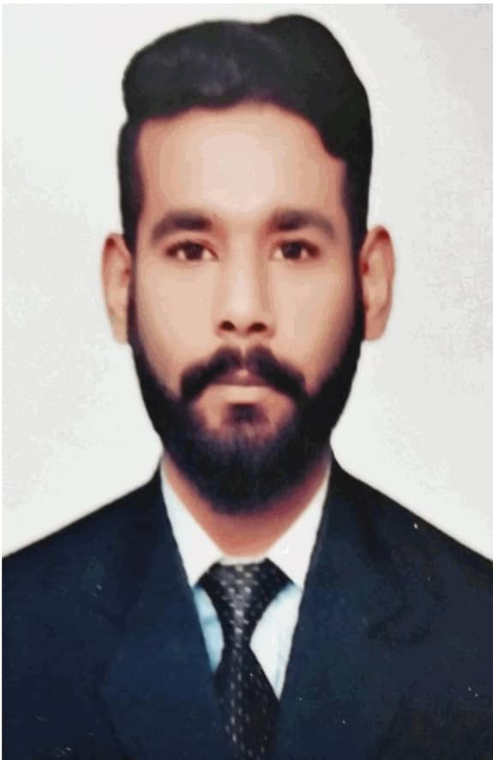  CONTACT  Address:  Al khan, Sharjah, United Arab Emirates  Phone:  +971 507731646  Email:  Usman.sarfraz@yahoo.com  LANGUAGES  English  Urdu  Hindi  Punjabi  PERSONAL DETAILS  Nationality : Pakistan  Date of Birth : 21/04/1994  Visa Status : Employment  Marital Status : Single |  | SUMMARY  A result oriented professional with nearly 3 years of experience spread across Client Relations Management, Business Development, Collection and Revenue Generation.  Banking collections / Sales, seeking an challenging opportunity where i can utilize my educational background and professionalism, enabling me to contribute towards the growth and success of the organization. A position where my experience and skills will allow me to make a positive contribution towards departmental goals and company profitability.  Proven experience in determining customer needs and offering solutions as per need based on different nationalities and cultural background. Recognized for successfully meet targets & nurturing fruitful relationships with customers.  - Personal Development.  - Logical Reasoning.  - Active listening  - Conflict Resolution.  - Team Building.  - Analytical Thinking and Decision Making  WORK EXPERIENCE  Jan’20 - Present  Tahseel - Hadaf AL Khaleej Debt Collection, UAE  Team Leader – Collections  March’19 – Dec’19  Tahseel - Hadaf AL Khaleej Debt Collection  Senior Collection officer Jan’18 – Feb’19  Tahseel - Hadaf AL Khaleej Debt Collection  Collection officer  Responsibilities:  - To follow up and collect on all overdue, delinquent (over credit limit cards) customers.  - Studying cases and determining the appropriate course of action for each individual case.  - Tracing & Negotiating for appropriate payment or settlement arrangements with customers.  - Responsible for calling customers and making field visits and meetings  - Identifying the reason of default and follow up for repayment.  - Handle number of calls (as per department set targets) & follow-up on customer’s commitment to pay.  - Send out confirmation letters to employers to confirm employment status and establish contact with the customer.  - Prepare daily / weekly progress report (daily performance tracker).  - Review collection MIS to measure own effectiveness, productivity & efficiency  - Manage multiple accounts for delinquency and debt collection efforts  July’16 – April’17  Silkbank Limited, Pakistan  Sales Executive – CASA  Responsibilities:  - To promote the sales of various personal banking products in the allocated markets & within the branch.  - Maintain relationships with clients visiting the branch by providing support, information & recommending new opportunities.  - Understand the customer need and offer him product as per his desire  - To achieve sales targets agreed with the Direct Sales Manager.  - To provide MIS & competitor feedback on a weekly basis.  - Managing achievements of sales objectives by setting sales targets.  - Assist in the implementation of sales & marketing strategies.  - Assist in resolving specifics default transactions on requests.  - Customer development is essential in this role and therefore the aim is to optimize at least 50 customers in your stipulated work time of 8 hours in a day alongside generating 25 quality leads per day qualifying the customer well.  EDUCATION  2012 - 2016  Masters in Sociology & Sociocultural studies  University of Punjab, Pakistan.  2010 - 2012  Intermediate (Pre engineering)  Punjab group of colleges, Pakistan  CORE VALUES & COMPETENCIES  - Efficiency & Commitment  - Consistency & Reliability  - Client service Orientation  - Computer Competency  - Integrity & Adaptability  REFERENCES  References available on request
  AREA OF EXPERTISE & COMPETENCIES

